34.93: a) Bouncing first off the convex mirror, then the concave mirror:
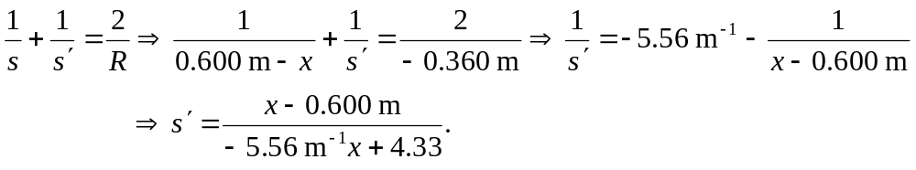
But the object distance for the concave mirror is just 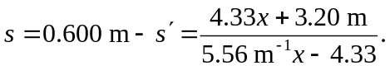
So for the concave mirror: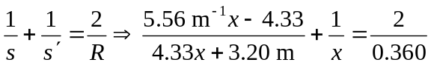
But the object position must be between the mirrors, so the distance must be the smaller of the two above, 0.24 m, from the concave mirror.
b) Now having the light bounce first from the concave mirror, and then the convex mirror, we have:
But the object distance for the convex mirror is just
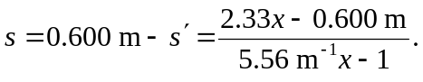
So for the convex mirror: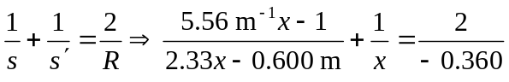
But the object position must be between the mirrors, so the distance must be 0.24 m from the concave mirror.

